**Recognizing Exercises from Physiotherapy Videos**

**1 Problem Statement**

Physical therapy (PT), also known as physiotherapy, is one of the associated health professions that aims at remediating impairments and promoting mobility and function by using mechanical force and movements, manual therapy, exercise therapy, and electro therapy. The success of physiotherapy treatment depends on whether the recommended exercises are being done in proper way. Hence, the treatment may not be successful due to patient’s non-compliance with the prescribed exercises. Hence, it is required for a patient to have as many sessions with a physical therapist as possible which may not be affordable to the patient in terms of the financial aspects. Hence, there is a need of developing an automated system to assess exercise quality to complement traditional PT.

**2 Background Work**:

There are various approaches for the identification and classification of a physiotherapy exercise from videos. Some of them are identifying the exercise with a Kinect camera. One major limitation of this approach is that only the video and depth streams from the Kinect sensor can be found. Although it is possible to extract the joint information from the video and depth frames, it is not a straightforward task, and it requires implementation of an image processing method. The activity of four leg muscles, recorded with EMG electrodes, and several related data sets monitoring physical activities (e.g., by wearing heart rate monitors, inertial measurement units), have been used for recognizing or classifying the type of activity. Another approach to assess coordinated human activity on the basis of trajectories, considered basketball and developed a probabilistic method to detect key events.

Analysis of the FINA09 diving dataset reveals that the temporal information, implicitly present in videos, is very important and the histogram of oriented gradient (HOG) features can be used for pose estimation. In another work, the authors addressed the issue of quality assessment and developed an approach in which the system is trained using an action dataset containing scores, for quality. Once the model is trained, it can assess sample and output a score for quality between 0 and 100. The authors tested their system on Olympic diving dataset in which the scores were given by judges.

**3 Materials and Methodology**

Figure 1 shows the work flow that can be used for identifying whether the physiotherapy exercises are being done properly.

**3.1 Data Collection and Dataset Preparation**: The UI-PRMD data set (http://webpages.uidaho.edu/ui-prmd/) consisting of a Vicon optical tracking system and a Microsoft Kinect camera from which the relative position of all subjects can be easily measured

**3.2 Methods**

**3.2.1 Video preprocessing :** The raw data will consist of a number of joint positions for each frame. An exercise sample (positive or negative) contains many such frames. However, due to differences in speed and execution, the samples do not have the same number of frames. The samples can be re-sampled to a fixed length of N frames, where the value of N can be set experimentally.

**3.2.2 Training and Testing:** Once the values ofthe initial parameters are obtained from the preprocessing phase, supervised training is performed. Subsequently, testing is performed using the validation set to evaluate the performance of the classifier using different measures such as accuracy, joint data precision, angle data precision.

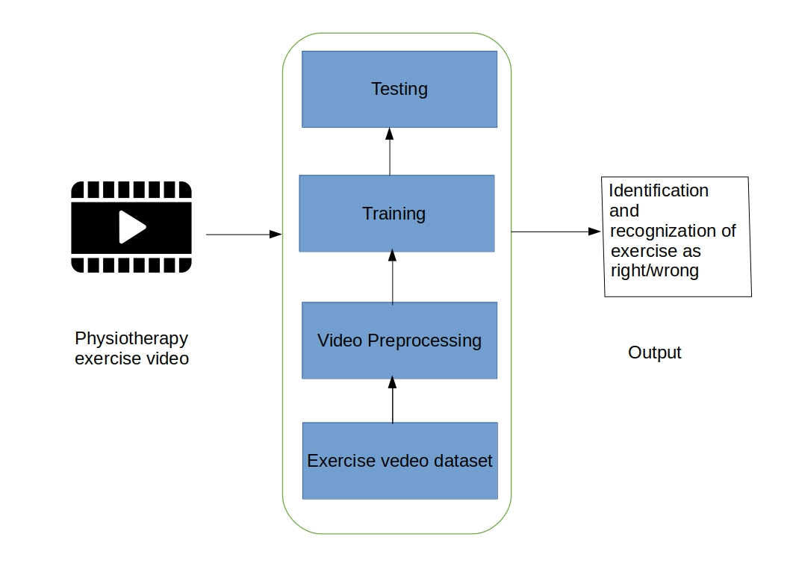

**Figure 1: Architecture of physiotherapy exercise detection system from video**

**4 Experimental Design**

**4.1 Software and Hardware Requirements** :For this implementation, python along with Theano can be used on GPU for training and testing.